

**MÜHENDİSLİK FAKÜLTESİ**

**Elektrik-Elektronik Mühendisliği**

**AD : Canberk**

**SOYAD : ŞAHİN**

**NUMARA: 21095835**

**DERS : EEM-201 (Devre Teorisi - 1)**

**5.48**

Suppose the strain gages in the bridge in Fig. 5.18 have the value 120 Ω ± 1%. The power supplies to the op amp are ± 15 V, and the reference voltage (Vref ) is taken from the positive power supply.

a) Calculate the value of Rf so that when the strain gage that is lengthening reaches its maximum Iength, the output voltage is 5 V

b) Suppose that we can accurately measure 50 Mv changes in the output voltage. What change in strain gage resistance can be detected in milliohms?

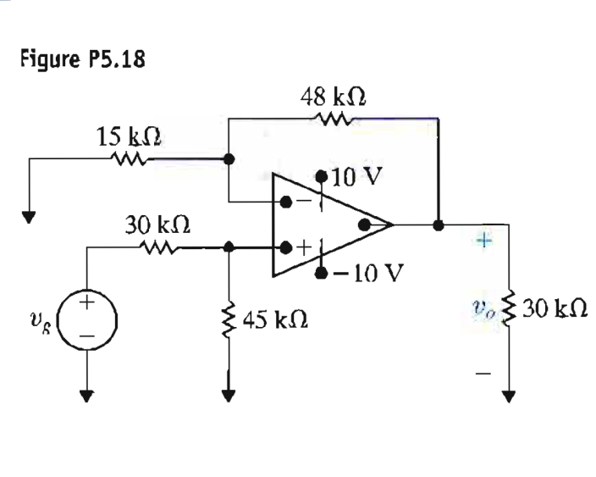

**6.14**

A 0.5 μF capacitor is subjecied to a voltage pulse having a duration of 2 s. The pulse is described by the following equations:

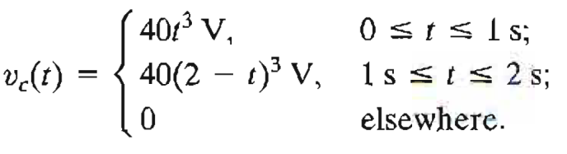

Sketch the current pulse that exists in the capacitor during the 2 s interval.

